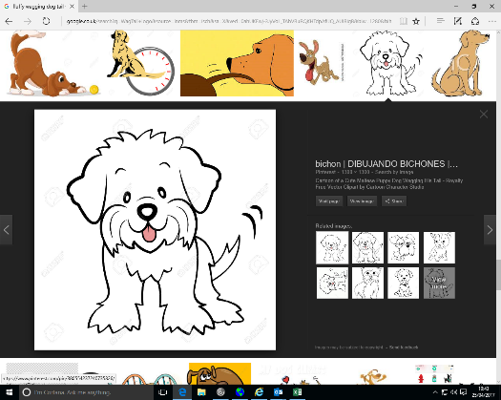

**WagTail**

**Dog Grooming**